TC-CSC-011
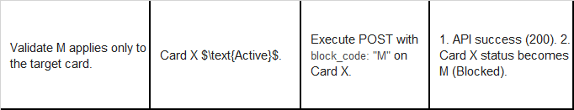
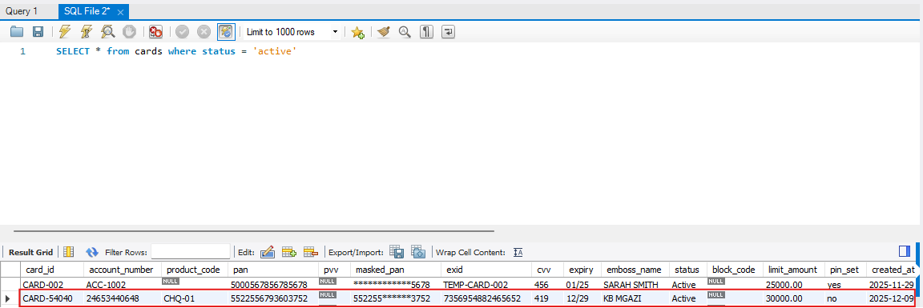
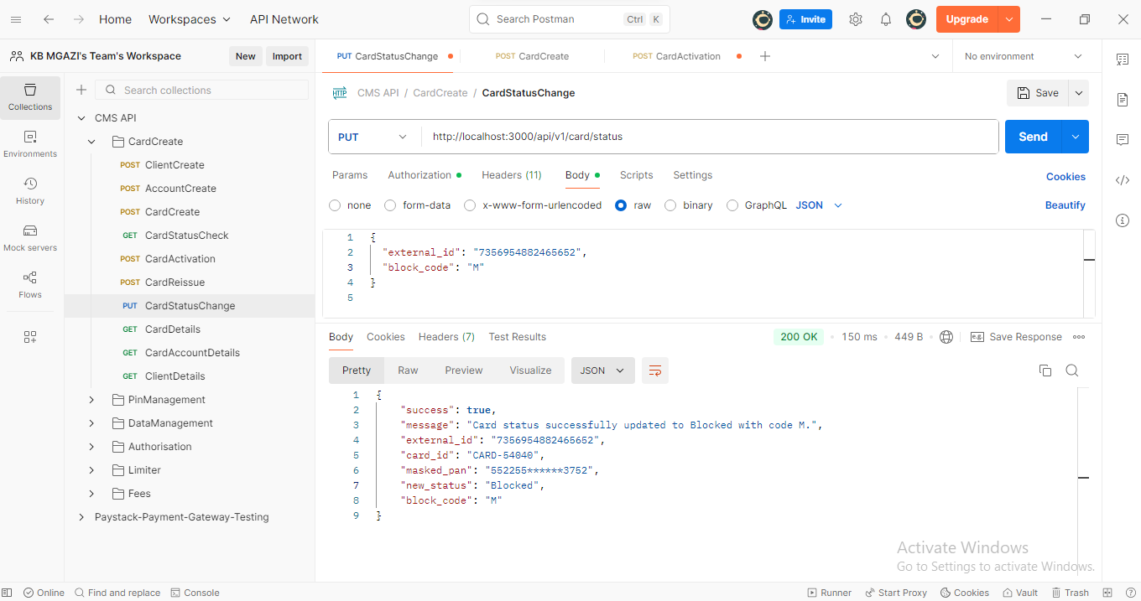
Request:
{
"external_id": "7356954882465652",
"block_code": "M"
}

Response:
{
"success": true,
"message": "Card status successfully updated to Blocked with code M.",
"external_id": "7356954882465652",
"card_id": "CARD-54040",
"masked_pan": "552255******3752",
"new_status": "Blocked",
"block_code": "M"
}

